PCC Electronic Document Management System
Prepared for: Data Privacy Office (DPO) · Office of Research and Development (ORD) / Research Ethics Committee (REC) · PCC IT
July 2026

Contents 2
Functional design document 3
1. Scope 3
2. The core model: one intake, two tracks, one joint output 3
3. Actors and roles 4
4. Module requirements 4
6. Reports 7
Workflow diagrams 8
DPREQ status lifecycle (DPO track) 8
REMIS endorsement, screening, review, and decision 9
REMIS monitoring and completion 10
DPNDA — OJT/trainee NDA workflow 10
Incident reporting workflow 11
System context 12
For context: decisions already made and confirmed (informational only) 14

Functional design document
Status: draft for stakeholder review and sign-off.

1. Scope

1.1 In scope
# | Capability | Serves
a | Online application for DPO and REC clearances | Both offices
b | Online submission of supporting requirements/documents | Both offices
c | Online signing of NDAs for researchers, OJTs, and trainees | DPO
d | Digital, searchable document repository | Both offices
e | Workflow automation (routing, notifications, status tracking) | Both offices
f | Report generation | Both offices

1.2 Out of scope (assumption — confirm)
- Financial/budget management for research grants
- HR/payroll systems for OJTs
- Learning management (LMS) functions for student teachers
- Public-facing research publication/portal features

1.3 Success criteria (assumption — confirm)
- 100% of DPREQ and REMIS applications processed without paper forms
- All OJT/community-service NDAs signed and stored electronically
- All defined reports (section 6) generatable on demand, without manual data compilation

2. The core model: one intake, two tracks, one joint output
A research application has one intake, two internal review tracks, one joint output:
- A researcher submits one form (“Form 1”).
- That single submission creates two parallel, independently-run records: a DPO track (data-privacy review) and an Ethics track (REMIS — research ethics review).
- Both tracks converge on a single joint clearance certificate, co-signed by the DPO and the Research Ethics Head. The certificate is not released to the applicant until both signatures exist — this is a hard system rule, not a documentation nuance.
- OJT/Trainee NDAs (a separate instrument, “Form 5”) are unrelated to research applications entirely — they belong to placements, not studies.

3. Actors and roles
Role | Office | Description
Researcher (internal / external) | Applicant | Submits research applications
OJT / trainee (internal / external) | Applicant | Placed for on-the-job training
Student teacher | Applicant | Observes/practices in PCC classes
Department/office coordinator | Host unit | Starts and countersigns OJT/trainee NDAs
DPO staff / reviewer | DPO | Screens and reviews DPO-track applications
DPO approver / head | DPO | Final DPO approval authority
Adviser → program head → dean | Academic (ORD) | Sequential academic endorsement of ethics applications
Ethics secretariat | ORD/REC | Administrative screening, tracking number assignment
Ethics reviewer | ORD/REC | Risk classification, substantive ethics review
Ethics committee chair | ORD/REC | Assigns reviewers, issues final ethics decision
System administrator | IT | User/role management, system configuration

4. Module requirements

4.1 Module 1 — DPREQ (data privacy clearance, DPO)
Purpose: review and clear research/data-collection activity for data-privacy compliance before it begins.
The system shall:
- Present one combined application form (Form 1) covering both data-privacy and ethics questions, submitted once per research application.
- Require applicant declaration and signature before submission.
- Require upload of: approved respondent-head letter (or pending request), research proposal, research instrument, adviser's endorsement letter, and (if minors are respondents) parental consent materials.
- Route submitted applications to DPO staff for completeness screening.
- Allow DPO staff to return an application with mandatory comments, or advance it to review.
- Allow DPO staff to endorse a reviewed application to a DPO approver, or reject it with reason.
- Block DPO approver approval until the associated Research Team NDA (section 4.2) is fully executed.
- Notify the applicant and DPO staff at submission, return, endorsement, approval/rejection, and clearance issuance.

4.2 Module 2 — DPNDA (non-disclosure agreements, DPO)
Two distinct NDA instruments:
a) Research Team NDA (Form 2) — signed by the research team lead and every co-researcher. The system shall:
- Auto-create a Research Team NDA record when Form 1 is submitted, pre-filled with the submitting researcher as team lead.
- Require every listed team member to sign before the record is marked complete.
- Block DPO-track approval (section 4.1) until this record is complete.
b) OJT/Trainee NDA (Form 5) — a separate workflow, unrelated to research applications. The system shall:
- Allow a Department Coordinator to create a placement record and associated NDA (trainee name, department, supervisor, duration).
- Notify the named trainee to review and sign, or decline with a reason.
- Require Department Coordinator countersignature after the trainee signs, completing the NDA in the same action.
- Generate a signed PDF of the completed NDA.
- Allow the coordinator to later upload an OJT Evaluation Report against a completed placement.

4.3 Module 3 — REMIS (research ethics review, ORD/REC)
Purpose: manage the ethics review lifecycle for a research application, from academic endorsement through monitoring and archiving.
The system shall:
- Route a submitted application through sequential academic endorsement: Adviser → Program Head → Dean. Each endorser may approve (advance), return with comments, or reject (terminal).
- On Dean approval, route to Ethics Secretariat for administrative completeness screening against a defined checklist; automatically generate a deficiency notice on an incomplete or returned-for-compliance result.
- Support risk classification (Minimal / Moderate / High) by an Ethics Reviewer, deriving the review track (Expedited / Committee / Full Board).
- Allow the Ethics Committee Chair to assign one or more Ethics Reviewers per application.
- Require every assigned Ethics Reviewer to submit a recommendation before a decision can be issued (panel review, not single-reviewer).
- Allow the Ethics Committee Chair to issue one of: Approved, Approved with Conditions, Deferred, or Disapproved.
- On a positive decision, sign the Ethics track's half of the joint clearance certificate.
- On clearance issuance, automatically transition the application into Monitoring.
- During Monitoring, accept monthly progress reports from the researcher and reviewer compliance verdicts against them (informational only — does not block anything).
- Accept a Final Ethics Completion Report from the researcher, which — on submission — closes and archives the study in the same action.
- Support standalone incident reporting (section 4.4) at any point during an active or monitored study, independent of the status lifecycle above.

4.4 Incident reporting (part of REMIS)
The system shall:
- Allow the study's researcher, or Ethics Secretariat/Reviewer/Chair, to file an incident against any REMIS application at any time.
- Capture incident type (Participant Complaint, Data Breach, Confidentiality Breach, Psychological Harm, Protocol Violation, Other), severity, and description.
- Immediately notify the Ethics Committee Chair and Ethics Secretariat on filing.
- Additionally notify DPO Staff directly when the incident type is Data Breach or Confidentiality Breach — the one point where the Incident module reaches across to the DPO side.
- Track incident status (Reported → Under Investigation → Corrective Action in Progress → Resolved → Closed) independent of the study's own status.
- Support an attached corrective action (required action, due date, status, verification) tracked independently of the incident's own status.

4.5 Shared infrastructure
The system shall:
- Maintain one user/role model shared by all modules, with role-based permission checks on every module action.
- Enforce a consistent, auto-generated file naming and repository placement convention for every uploaded or generated document.
- Capture an e-signature (typed name + timestamp + IP/device, plus a drawn-signature image for visual familiarity) on every signing event, and lock signed documents from further edits.
- Provide in-app and email notification channels, with role-specific dashboards (new submissions, pending-my-action, returned/awaiting-applicant, overdue monitoring, recently completed).
- Maintain an immutable, filterable audit trail of every record creation, status change, document upload, signature event, and role change.
- Provide applicants a simplified status tracker, and internal reviewers the full status and comment history, for any record.

4.6 Public verification
The system shall:
- Provide a public, unauthenticated page where anyone can enter a DPREQ/REC tracking number, or scan a certificate's QR code, and receive: valid/expired status, both tracking numbers, issue date, expiry date — and nothing else (no names, no study details).
- Only ever resolve against a clearance certificate that has both required signatures.

6. Reports
Report | Owner | Key metrics
Applications by department | Shared | Application counts by status, by department
Compliance monitoring report | Shared | Compliant / minor / major / non-compliant counts
Incident summary | ORD (DPO cc'd on breach types) | Incident counts by type, severity, status; time-to-resolution
Application by risk level | ORD | Minimal/Moderate/High breakdown
Reviewer workload | ORD | Active assignments, completed reviews, turnaround time per reviewer
Annual ethics report | ORD | Full-year submission/approval/rejection summary
Archive studies report | ORD | Archived studies list with outcome
NDAs per department/grade level | DPO | Completed NDA counts, cross-tabbed
Pending DPO approvals | DPO | In-flight applications with reasons/comments
Student teachers per grade/dept/school | DPO | Placement counts, cross-tabbed
OJTs accommodated per month/year | DPO | Placement counts, cross-tabbed, trended
OJT/student teacher whereabouts | DPO | Active placements as of a given date
Departments with/without OJT evaluation reports | DPO | Compliance list, two-sided

Workflow diagrams
Each diagram traces the exact status names used by the system, cross-checked against the running code, not just the design docs.

DPREQ status lifecycle (DPO track)
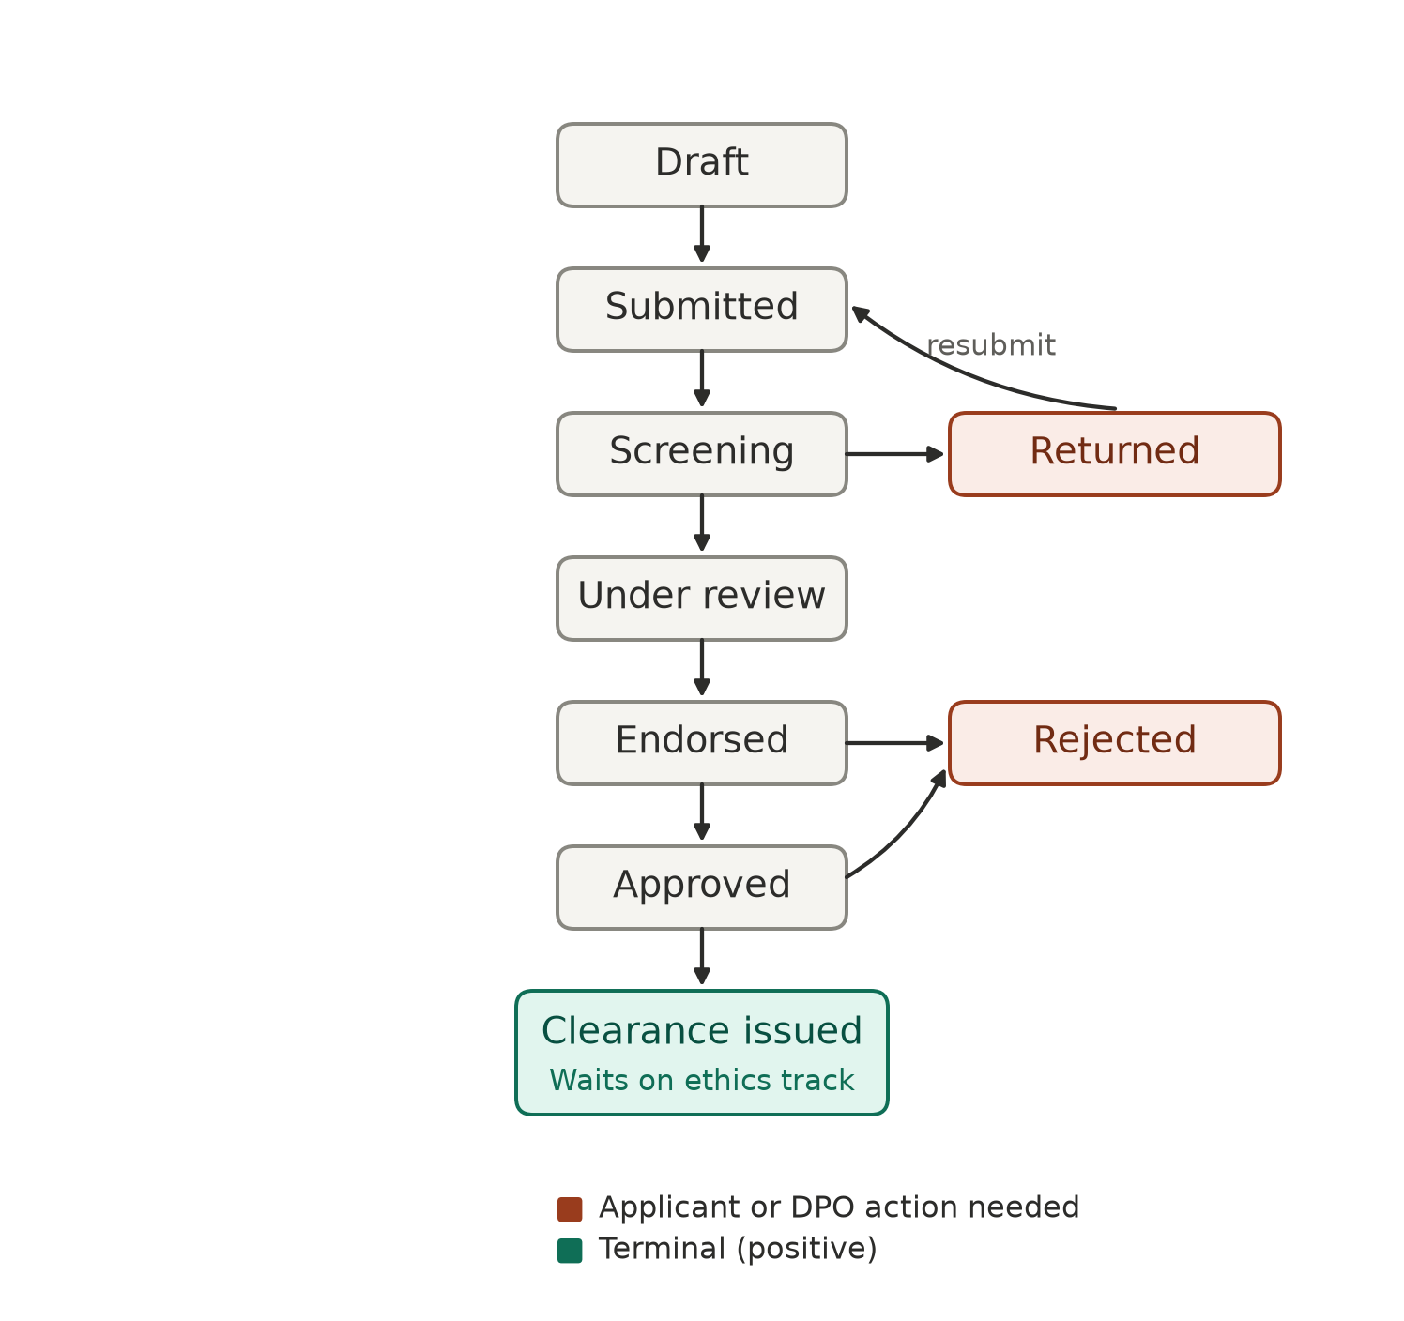
Figure 1. An application moves from draft through screening, review, endorsement, and approval, converging on a joint clearance once the ethics track also signs.

REMIS endorsement, screening, review, and decision
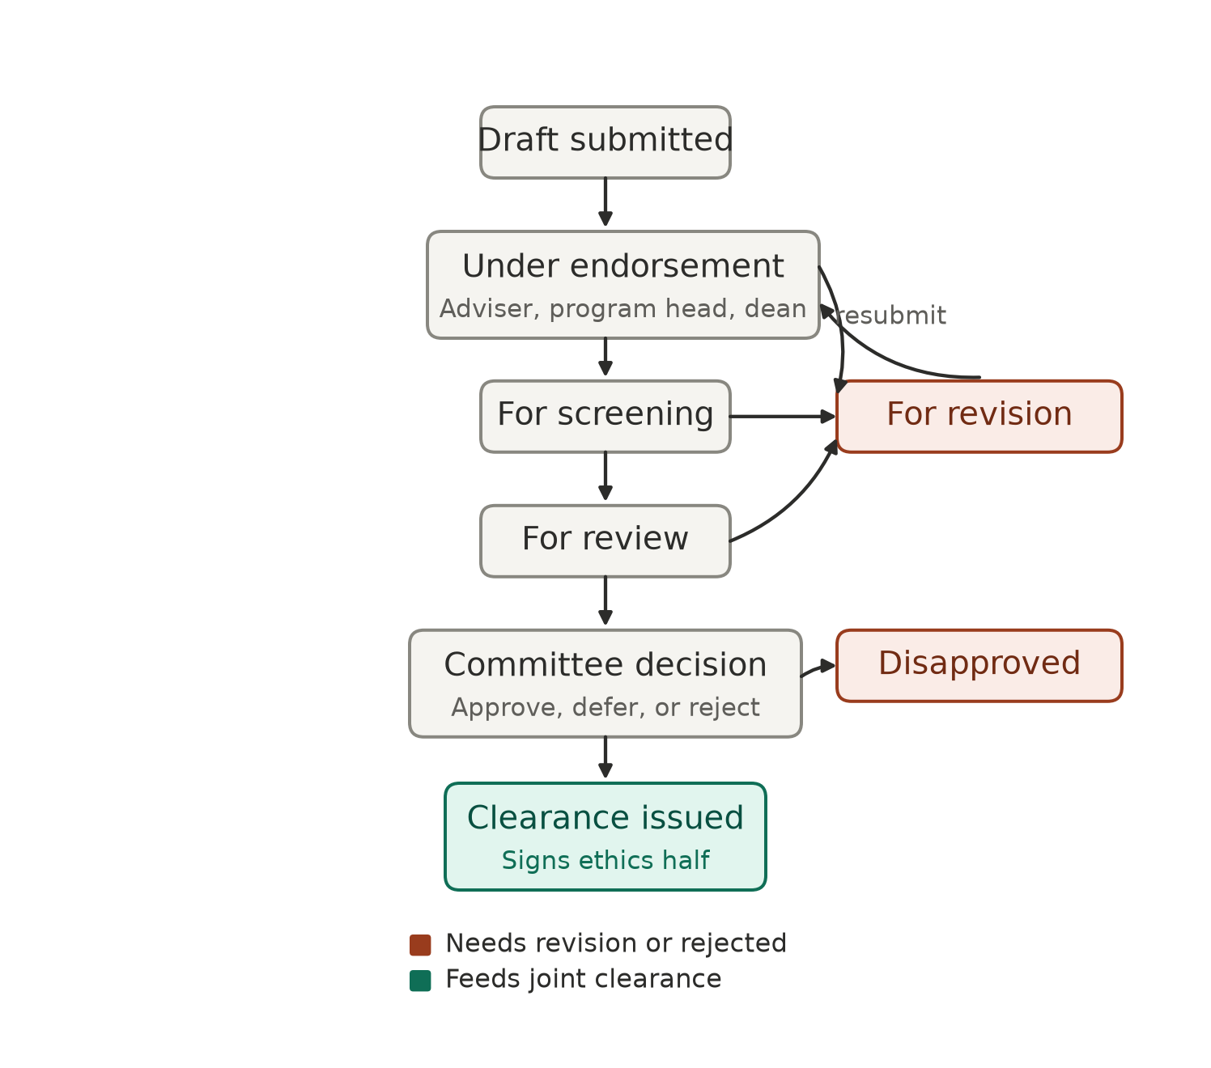
Figure 2. The ethics track: academic endorsement (Adviser → Program Head → Dean), administrative screening, risk-tiered review, and the committee's final decision.

REMIS monitoring and completion
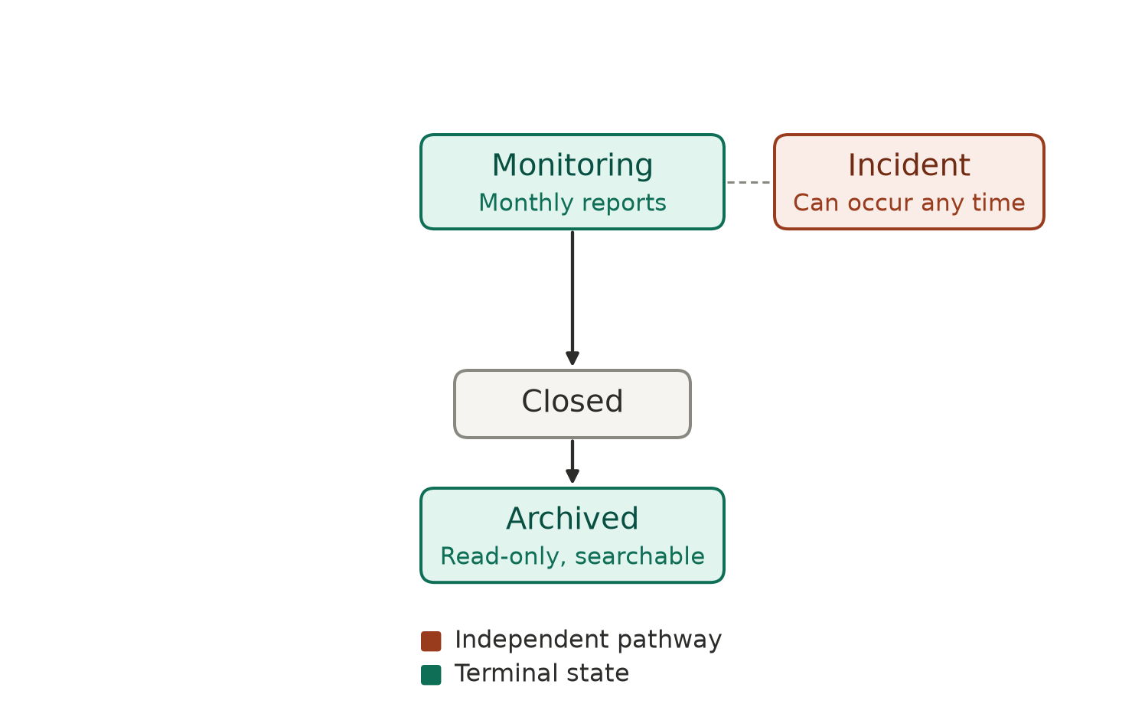
Figure 3. An approved study is monitored monthly until a final completion report closes and archives it. Incidents (figure 5) can occur at any point, independent of this lifecycle.

DPNDA — OJT/trainee NDA workflow
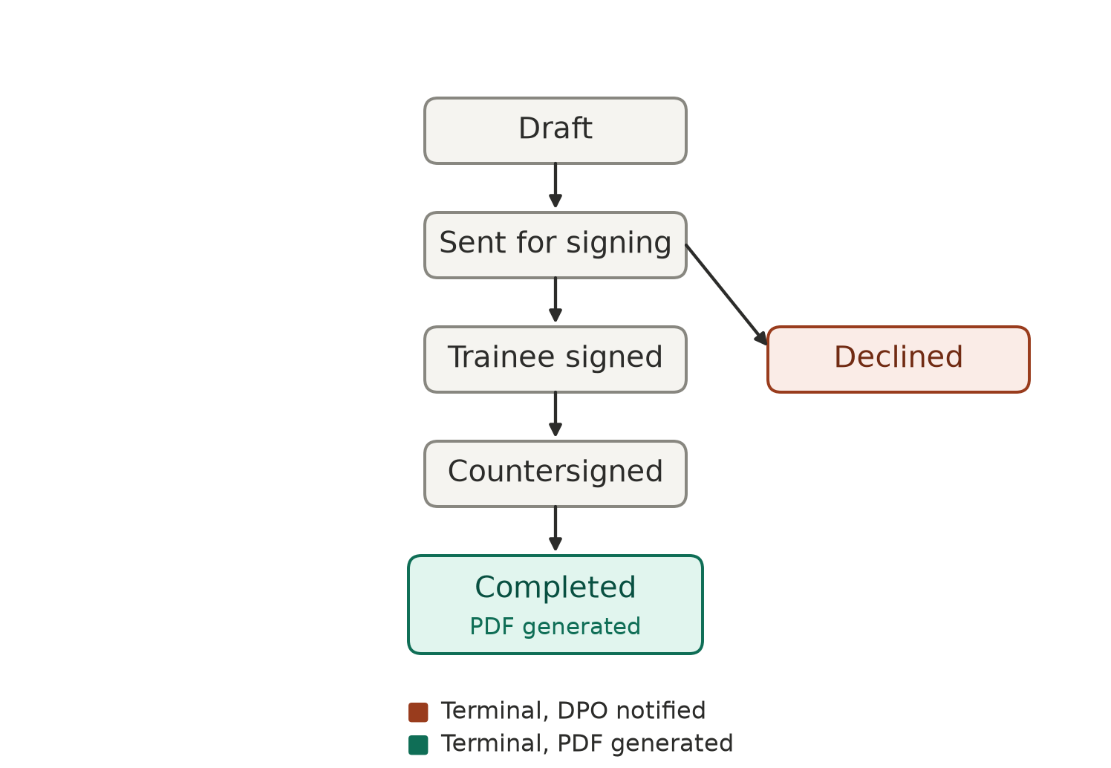
Figure 4. A separate workflow from the research application flow above — started by the Department Coordinator, not the trainee.

Incident reporting workflow
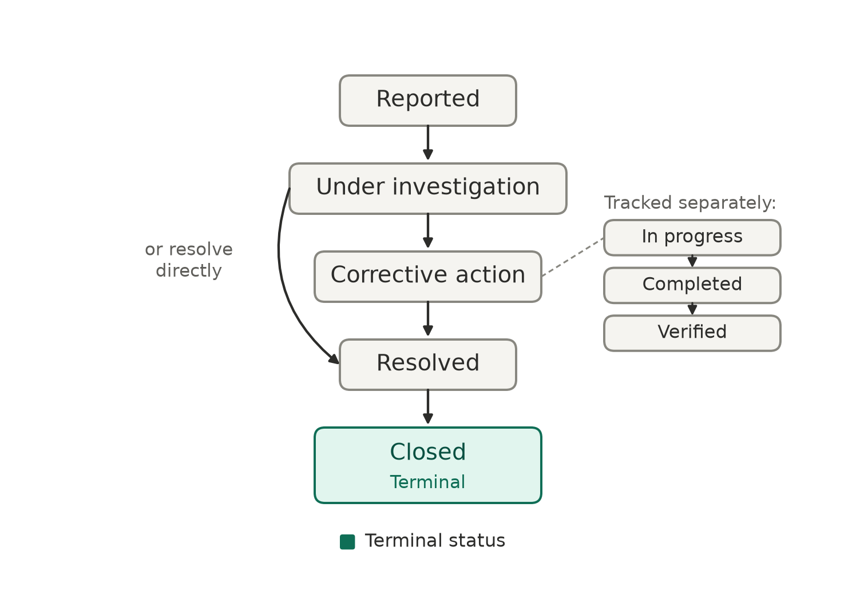
Figure 5. Incidents move through their own status lifecycle; a corrective action, if attached, is tracked independently through its own in progress / completed / verified states.

System context
A stakeholder-level view of the system: what PCC-EDMS is, who touches it, and how information flows between the two owning offices. Deliberately excludes implementation detail — no class names, table names, or schema.
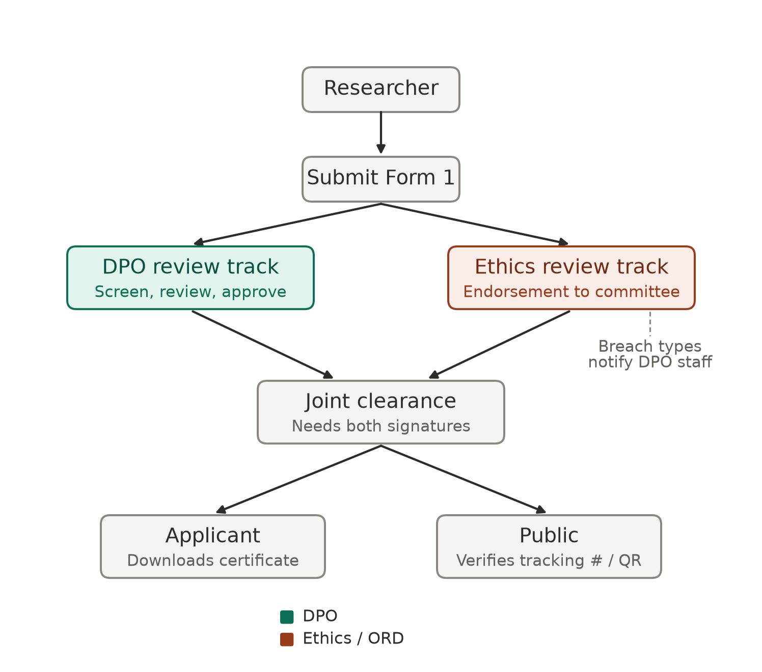
Figure 6. One front door (a single application form), two independent back-office tracks, one convergence point (the joint clearance certificate).
Reading this diagram:
- One front door: researchers interact with a single intake form, not separate DPO and Ethics forms.
- Two independent back-office tracks: DPO's review and the Ethics Committee's review happen in parallel and don't wait on each other — except at the very end.
- One convergence point: the joint clearance certificate is the only place the two tracks' outputs meet, and it enforces a hard rule — no release until both offices have signed.
- One cross-office notification: REMIS-side data-breach or confidentiality-breach incidents are the one case where the Ethics side directly notifies DPO.
- DPNDA is separate: OJT/trainee NDAs are not part of the research-application flow at all — they belong to placements, run by Department Coordinators.
- Reporting reads across everything: both offices get reports computed from the same underlying application data, without manual compilation.

For context: decisions assumed:
- Monitoring/progress-report cadence: monthly (most studies finish in 3–4 months).
- Bulk CSV import for OJT batch role assignment: required and built.
- SMS notifications: deliberately not built — the project runs on free infrastructure aside from hosting; email covers the required notification channel.
- A separate “Discontinued/Withdrawn” workflow branch: declined — a stalled study can remain in Monitoring indefinitely.
- Multi-version NDA template management: declined for now — the current fixed NDA template is stable.
- Panel review (multiple Ethics Reviewers per application, consolidated by the Chair): confirmed and built.
- Database engine: MySQL 8.0+. Frontend/backend integration: Inertia.js (React + Laravel).

UI Components:

Page Header:
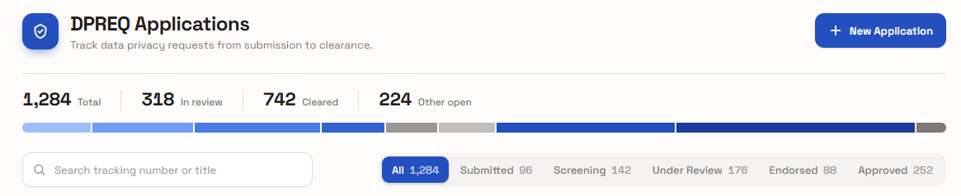
Please note that the ‘blue’ colors will be replaced with maroon/dark red (as the system’s primary color) along integration.

Table and Pagination:
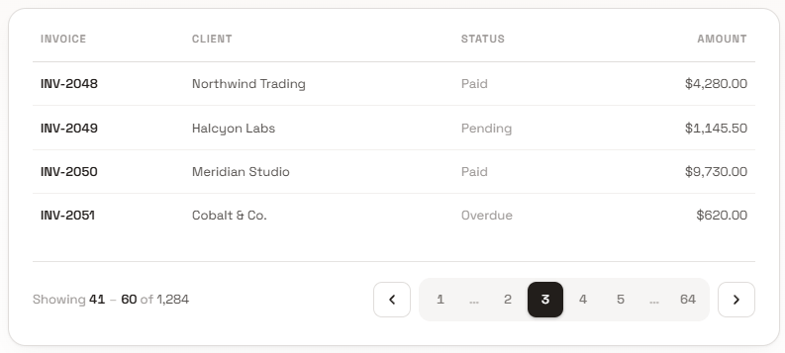

Mobile:
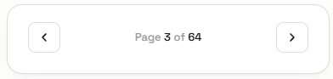

Login / Landing Page:
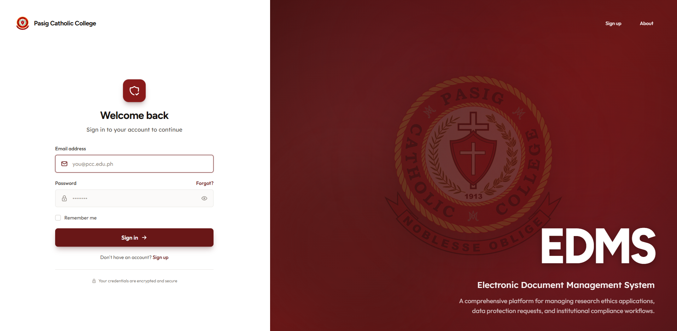

About Page:

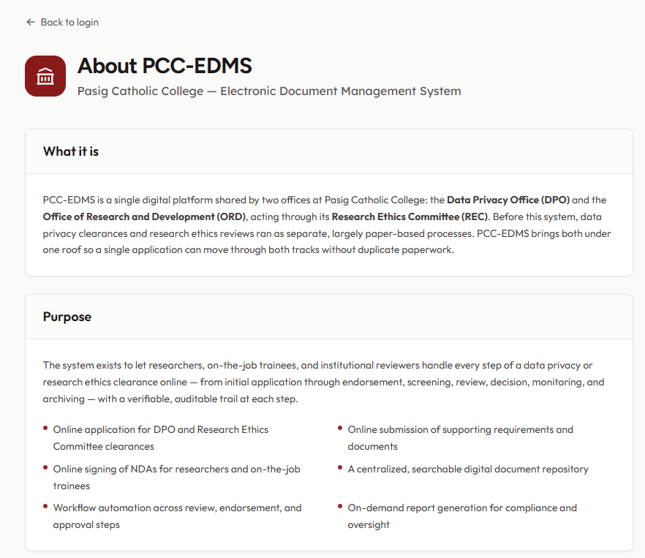

Sign-up Page:

